Carl Gauss (1777 – 1855)
was a great German mathematician who did important work in number theory, algebra, statistics, mechanics, electrostatics, and astronomy. He also established differential geometry, later used by Einstein to redefine gravity using general relativity.

Richard Feynman (1918 – 1988)
was an American theoretical physicist known for his fundamental work in quantum electrodynamics, with deep consequences for the physics of elementary particles. He introduced Feynman diagrams, a graphical representation of interactions between different particles. He received the Nobel Prize in Physics in 1965.


Edwin Hubble (1889 – 1953)
was an American astronomer who showed that there were many other galaxies beyond the Milky Way Galaxy in which we live. He also measured galaxies’ velocities to be proportional to their distances from us, suggesting an expanding universe and a Big Bang, as predicted by general relativity.


Emmy Noether (1882 – 1935)
was a great German mathematician who did important work in abstract algebra and theoretical physics. Noether’s theorem explains the connection between symmetries of the universe and conservation laws, like conservation of energy and momentum, which are central to physics.
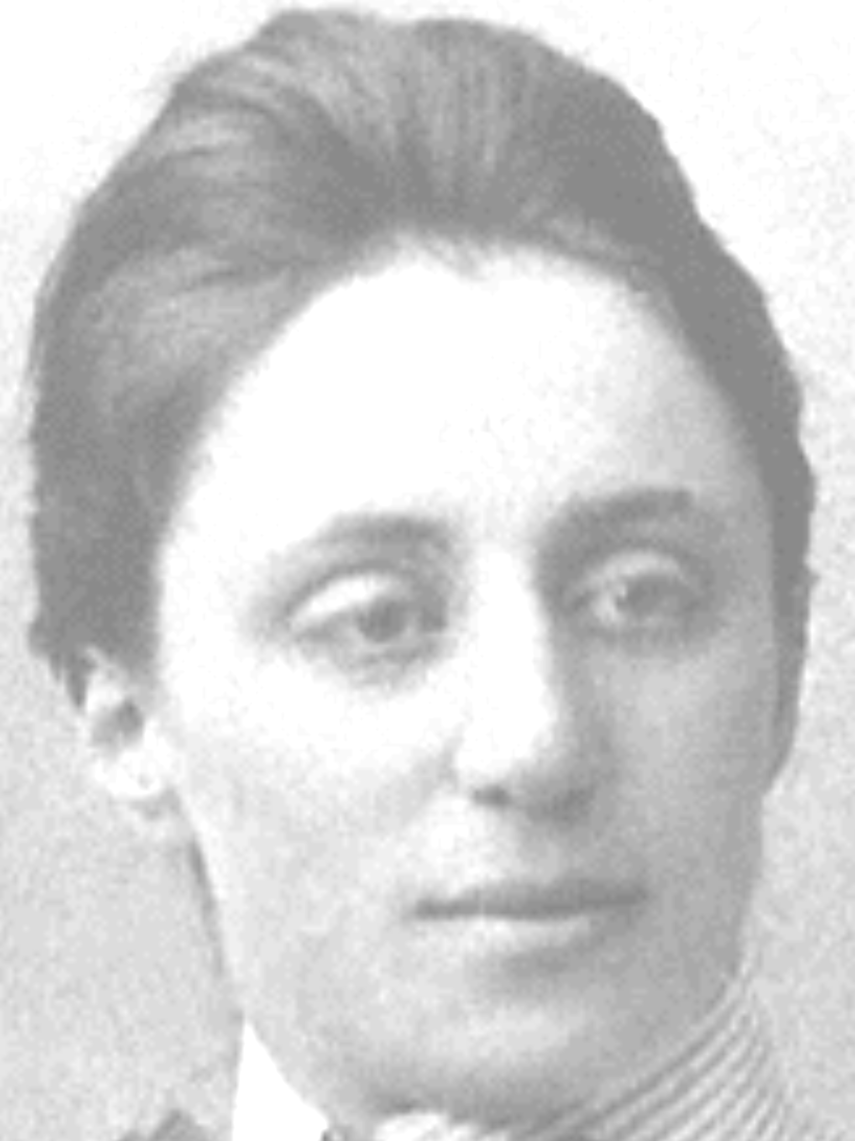
Albert Einstein (1879 – 1955)
unified space and time with special relativity and redefined gravity using general relativity, the idea that matter curves spacetime. His theory predicted the Big Bang, black holes, dark energy and the curvature of light around the Sun. Unlike Newton’s theory, it also explains gravity as accurately as can be measured.

Marie Curie (1867 – 1934)
was a Polish and naturalized French physicist and chemist who did early research on radioactivity and discovered two elements, radium and polonium. She was the first person to win two Nobel Prizes and the only person to win in multiple sciences, physics and chemistry.

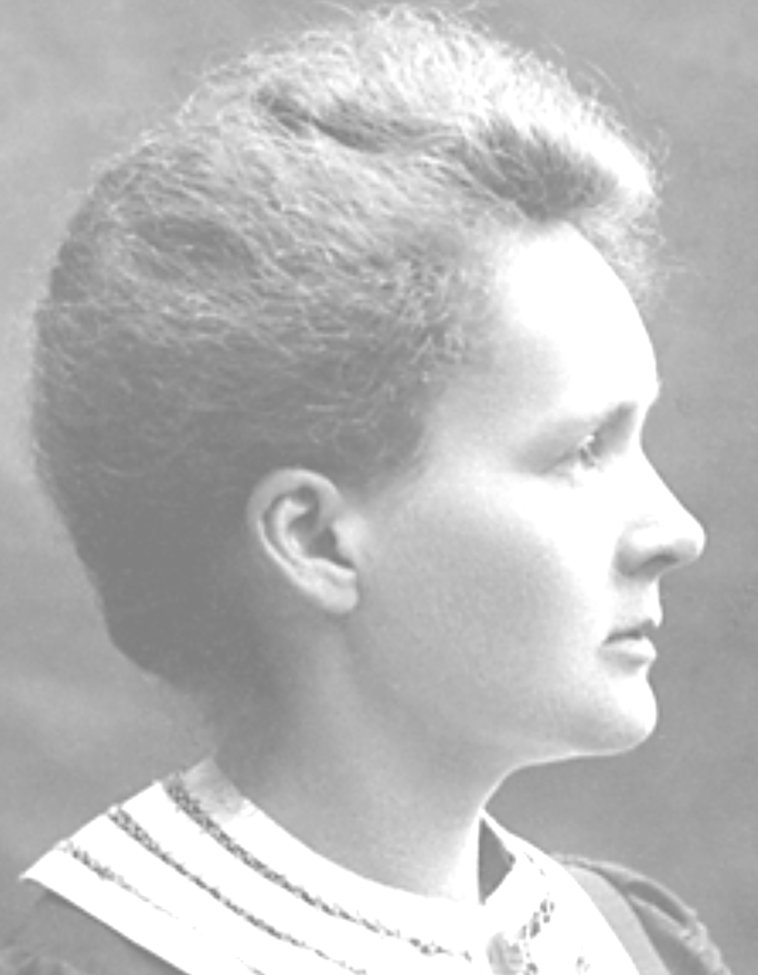
Charles Darwin (1809 – 1882)
was an English naturalist and geologist who proposed that all species of life are related. His theory, called natural selection, shows how small changes between parents and their children which help with survival can lead to the great diversity of life seen on the Earth today.

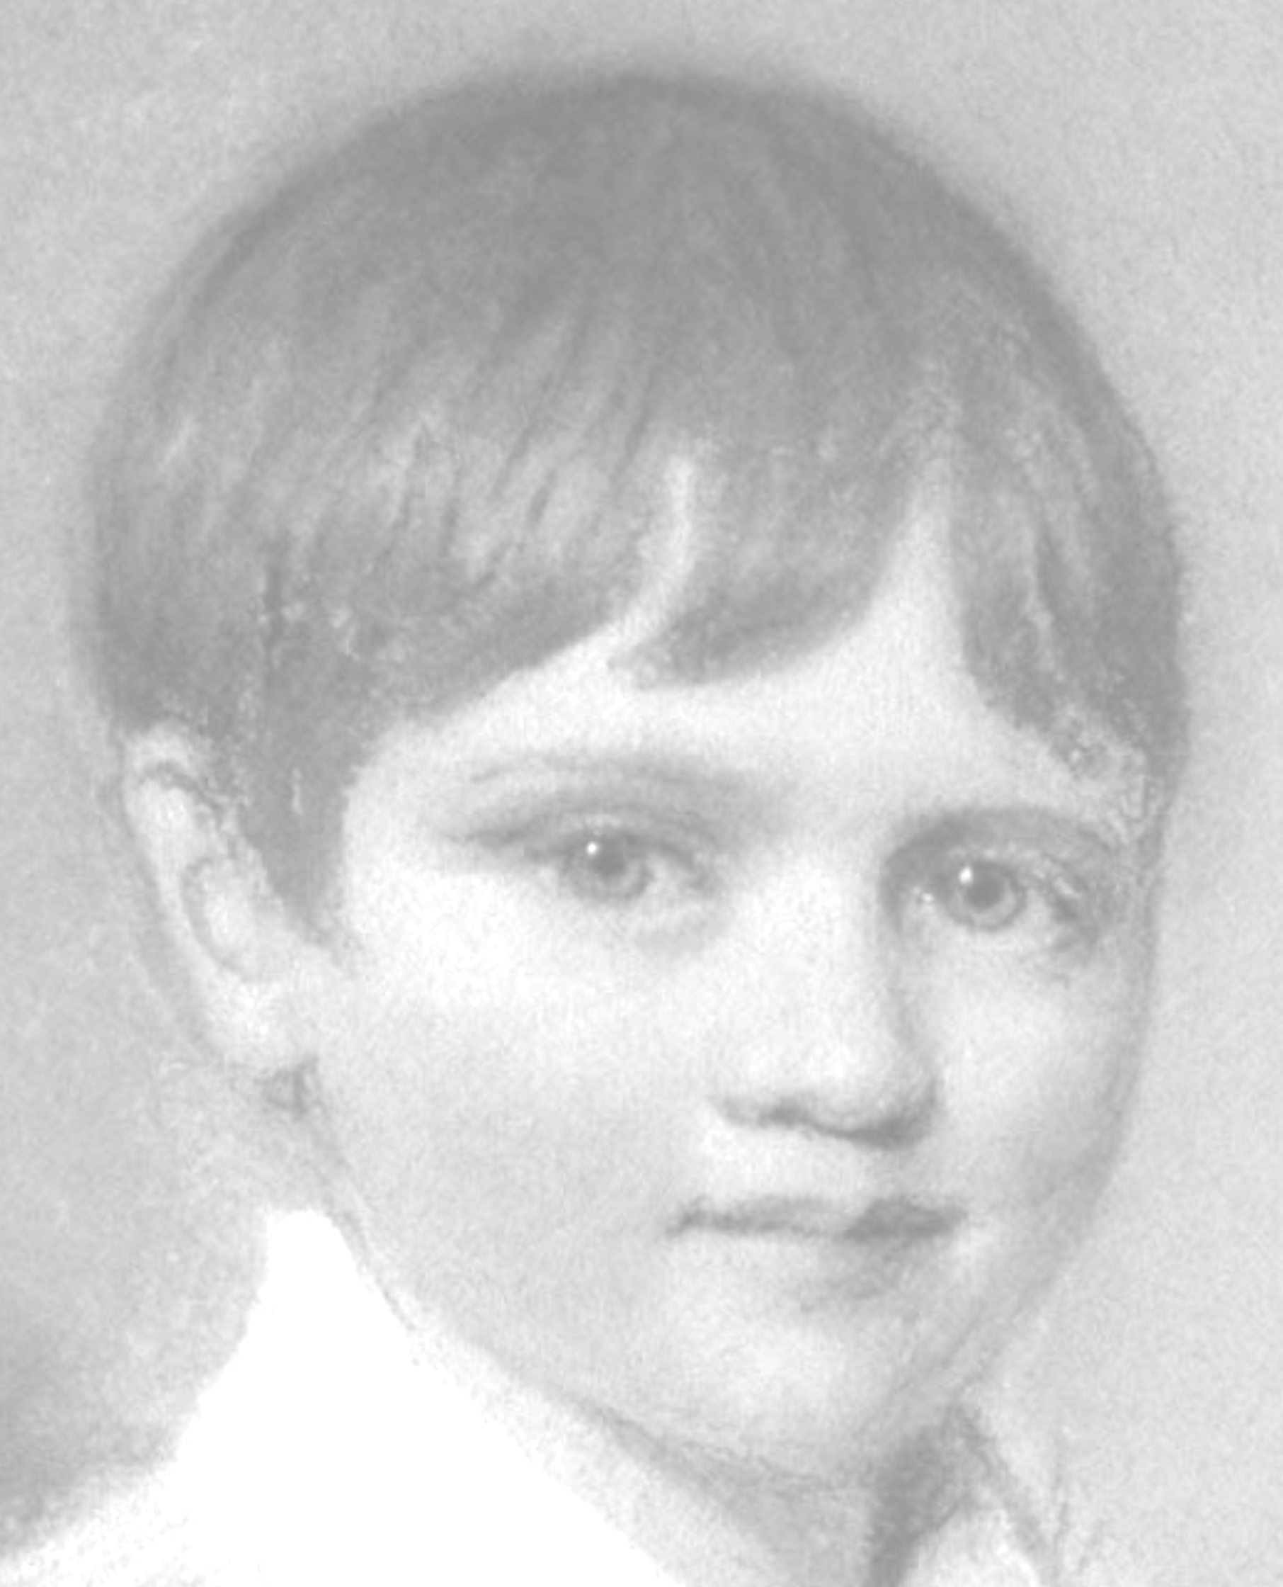
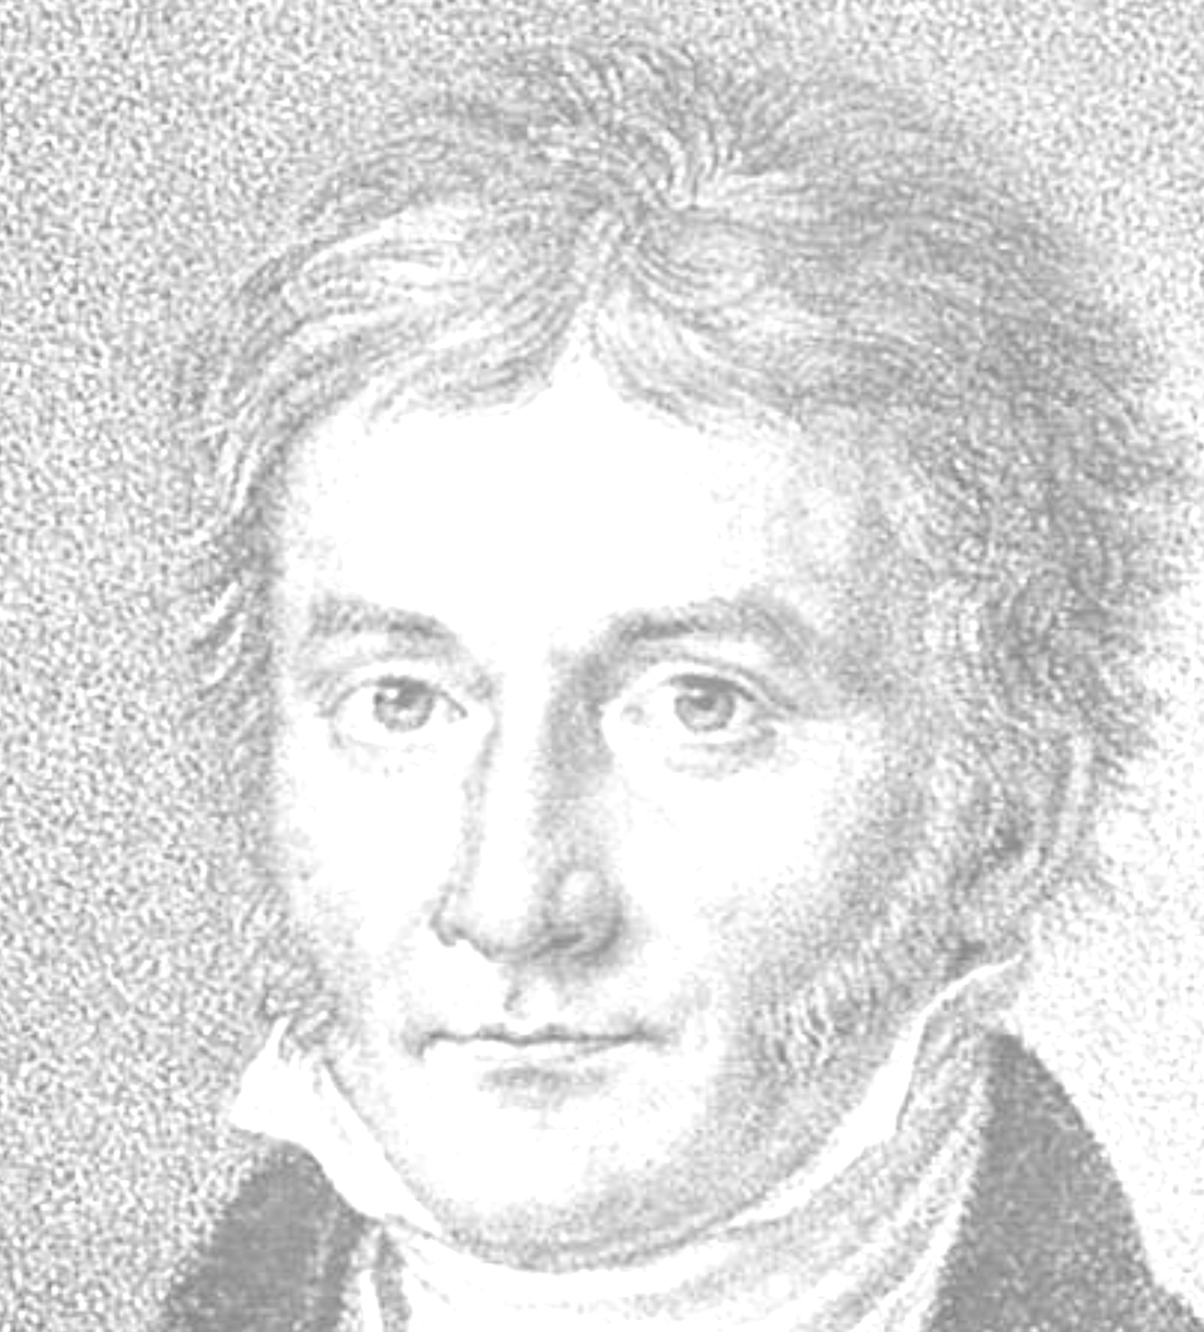
Isaac Newton (1643 – 1727)
was an English physicist and mathematician who was the first to show that gravity, which causes a rock to fall to the ground, is also what describes the motions of planets, moons, and comets. He also invented calculus to be able to express his theory in precise mathematical terms.

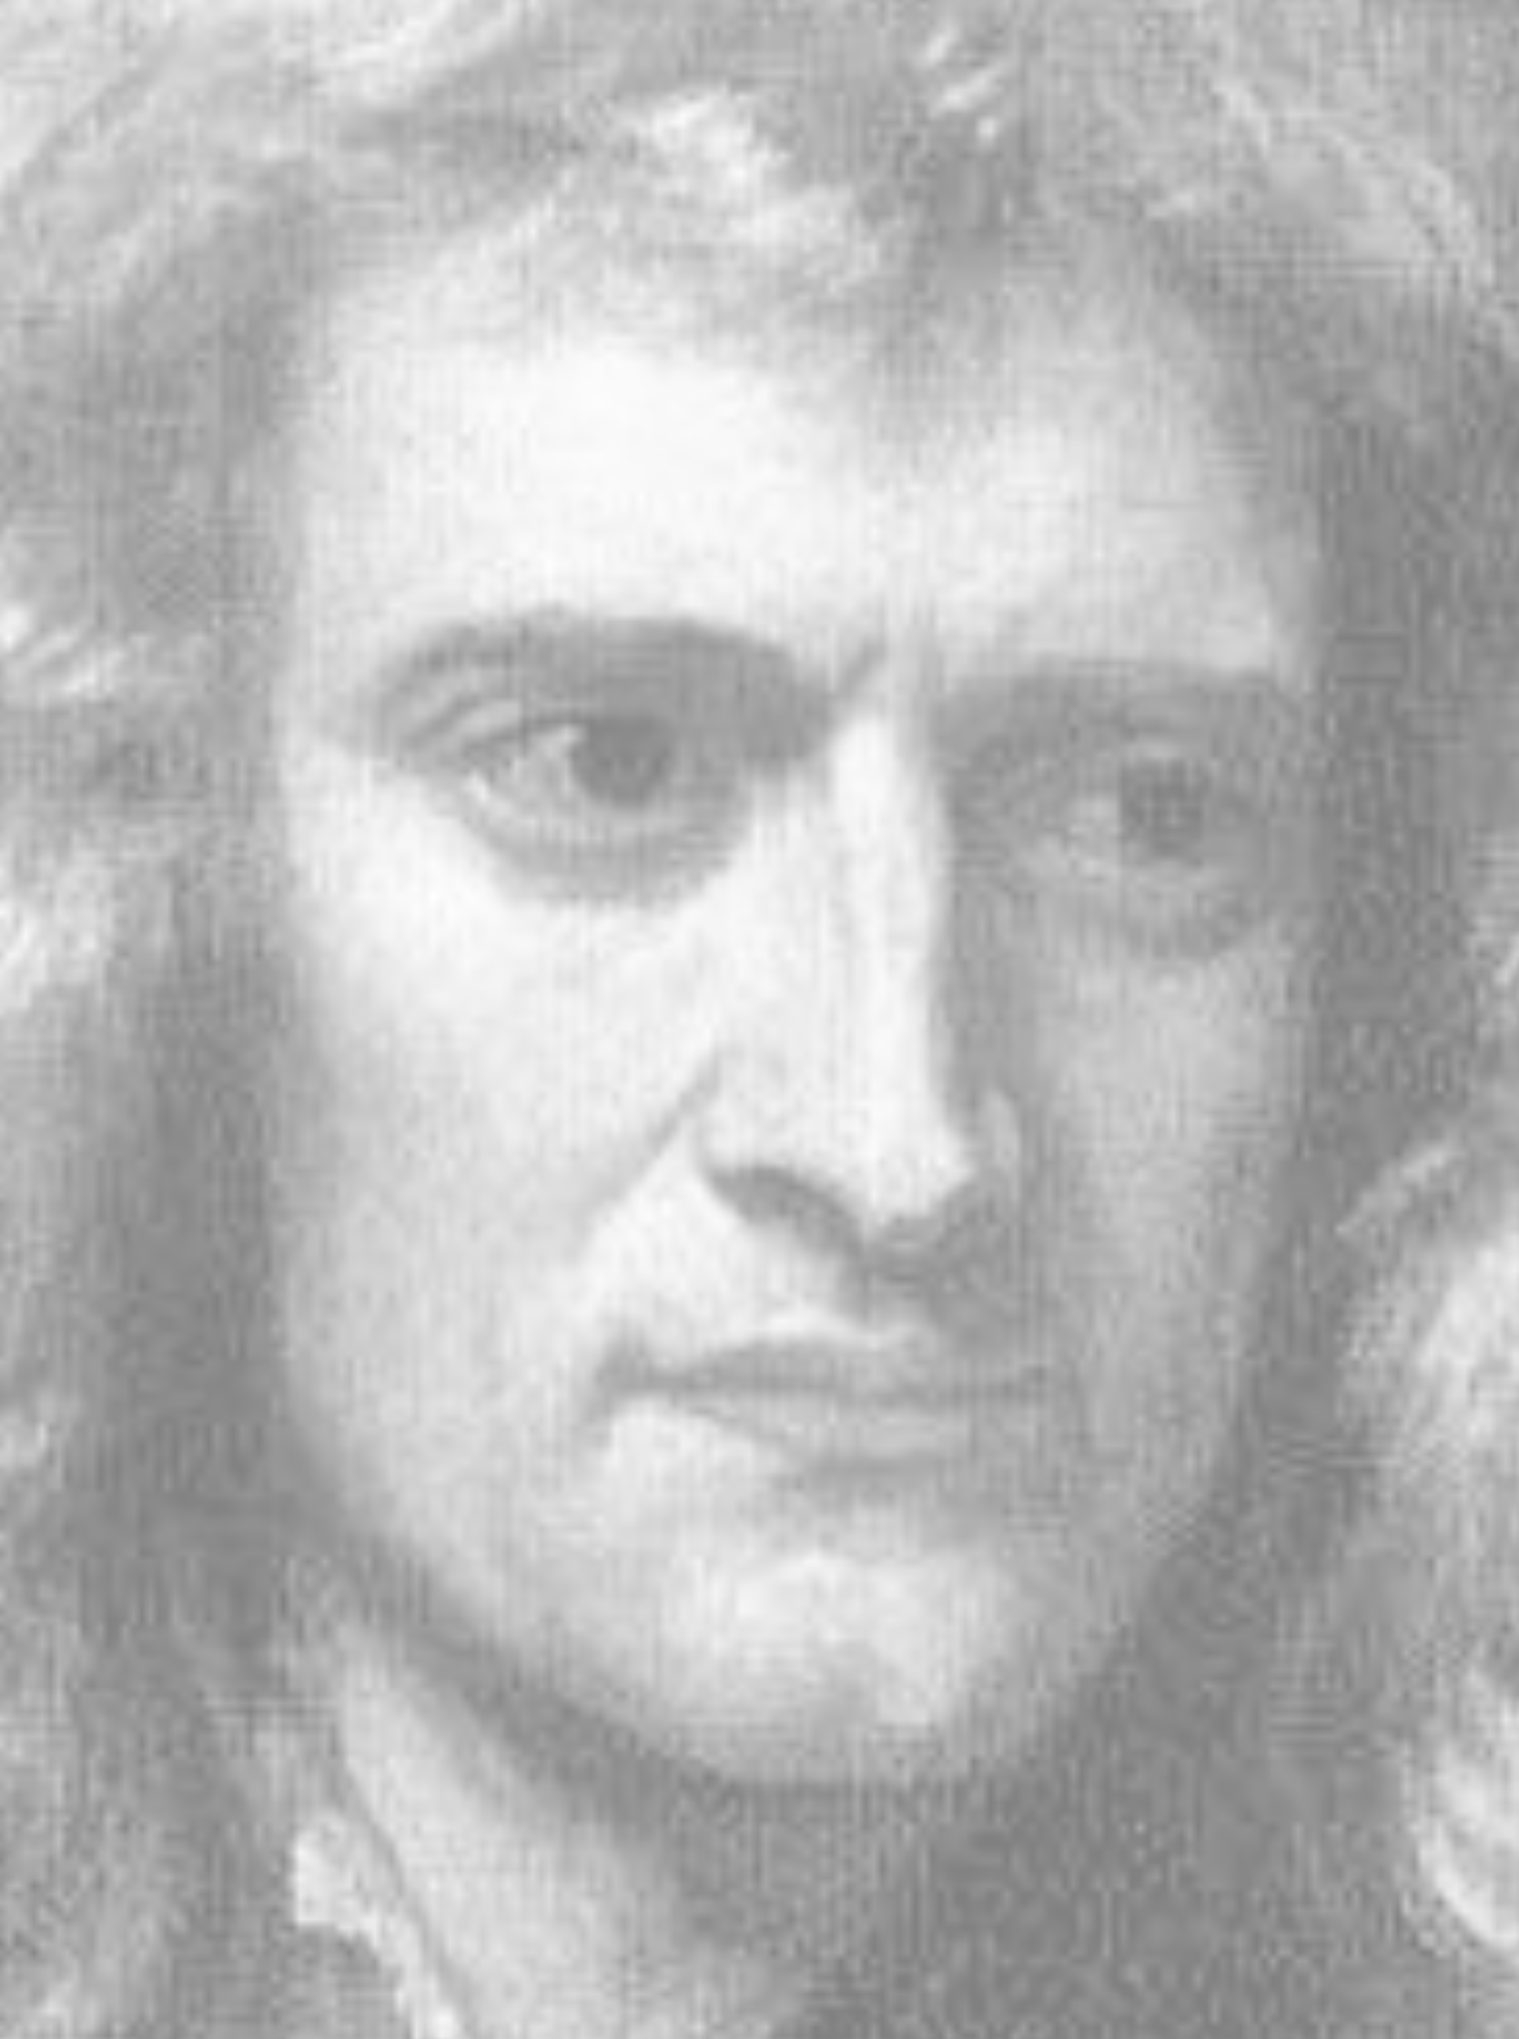
Print more golden thank yous for free at GoldenThankYous.com.
Great Scientists, Series 1, #8
Great Scientists, Series 1, #6
Great Scientists, Series 1, #4
Great Scientists, Series 1, #2
Great Scientists, Series 1, #7
Great Scientists, Series 1, #5
Great Scientists, Series 1, #3
Great Scientists, Series 1, #1
Print more golden thank yous for free at GoldenThankYous.com.
Print more golden thank yous for free at GoldenThankYous.com.
Print more golden thank yous for free at GoldenThankYous.com.
Print more golden thank yous for free at GoldenThankYous.com.
Print more golden thank yous for free at GoldenThankYous.com.
Print more golden thank yous for free at GoldenThankYous.com.
Print more golden thank yous for free at GoldenThankYous.com.
Learn more at TrevorTheTimeTraveler.com.
Learn more at TrevorTheTimeTraveler.com.
Learn more at TrevorTheTimeTraveler.com.
Learn more at TrevorTheTimeTraveler.com.
Learn more at TrevorTheTimeTraveler.com.
Learn more at TrevorTheTimeTraveler.com.
Learn more at TrevorTheTimeTraveler.com.
Learn more at TrevorTheTimeTraveler.com.

X = 4
X = 8
X = 9
X = 7
X = 6

X = 2
X = 3
X = 5
Print more golden thank yous for free at GoldenThankYous.com.
Algebra Problems, Series 1, #8
Algebra Problems, Series 1, #6
Algebra Problems, Series 1, #4
Algebra Problems, Series 1, #2
Algebra Problems, Series 1, #7
Algebra Problems, Series 1, #5
Algebra Problems, Series 1, #3
Algebra Problems, Series 1, #1
Print more golden thank yous for free at GoldenThankYous.com.
Print more golden thank yous for free at GoldenThankYous.com.
Print more golden thank yous for free at GoldenThankYous.com.
Print more golden thank yous for free at GoldenThankYous.com.
Print more golden thank yous for free at GoldenThankYous.com.
Print more golden thank yous for free at GoldenThankYous.com.
Print more golden thank yous for free at GoldenThankYous.com.
Learn more at TrevorTheTimeTraveler.com.
Learn more at TrevorTheTimeTraveler.com.
Learn more at TrevorTheTimeTraveler.com.
Learn more at TrevorTheTimeTraveler.com.
Learn more at TrevorTheTimeTraveler.com.
Learn more at TrevorTheTimeTraveler.com.
Learn more at TrevorTheTimeTraveler.com.
Learn more at TrevorTheTimeTraveler.com.
Solve for X:
X + 10 = 12

Solve for X:
X + 1 = 7

Solve for X:
X + 9 = 13

Solve for X:
X + 3 = 12

Solve for X:
X + 5 = 12

Solve for X:
X + 8 = 16

Solve for X:
X + 5 = 10

Solve for X:
X + 7 = 10

Answer: even, odd, even.

5

8

13

21
34

55

89

144

Squares with sides equal to the Fibonacci numbers may be arranged as shown in this picture. The squares fit perfectly together since the side length of each square is exactly the sum of the previous two smaller squares. As the numbers get larger, they go up by a factor which converges to the golden ratio
$$\frac{1+\sqrt{5}}{2}$$
which is about 1.6. The spiral in the picture goes around infinitely many times. Each time it goes around one quarter turn, it shrinks by a factor equal to the golden ratio. This is why this spiral is called the golden spiral.

Ans: 233
Print more golden thank yous for free at GoldenThankYous.com.
Math of Golden Thank Yous, Series 1, #8
Math of Golden Thank Yous, Series 1, #6
Math of Golden Thank Yous, Series 1, #4
Math of Golden Thank Yous, Series 1, #2
Math of Golden Thank Yous, Series 1, #7
Math of Golden Thank Yous, Series 1, #5
Math of Golden Thank Yous, Series 1, #3
Math of Golden Thank Yous, Series 1, #1
Print more golden thank yous for free at GoldenThankYous.com.
Print more golden thank yous for free at GoldenThankYous.com.
Print more golden thank yous for free at GoldenThankYous.com.
Print more golden thank yous for free at GoldenThankYous.com.
Print more golden thank yous for free at GoldenThankYous.com.
Print more golden thank yous for free at GoldenThankYous.com.
Print more golden thank yous for free at GoldenThankYous.com.
Learn more at TrevorTheTimeTraveler.com.
Learn more at TrevorTheTimeTraveler.com.
Learn more at TrevorTheTimeTraveler.com.
Learn more at TrevorTheTimeTraveler.com.
Learn more at TrevorTheTimeTraveler.com.
Learn more at TrevorTheTimeTraveler.com.
Learn more at TrevorTheTimeTraveler.com.
Learn more at TrevorTheTimeTraveler.com.
Counting by two’s gives us the even numbers:
0, 2, 4, 6, 8, 10, 12, 14, 16, 18, 20, 22, 24, …
Adding one to each number gives odd numbers:
1, 3, 5, 7, 9, 11, 13, 15, 17, 19, 21, 23, 25, …
What patterns can you see?
What digits come at the end of even numbers?
What digits come at the end of odd numbers?
Why is this?

Even numbers come out evenly when you split them into two rows. Odd numbers do not.

1 . (odd) Pictures help us see ideas.
2 : (even)
3 :. (odd) 4 + 6 = 10
4 :: (even) :: + ::: = :::::
5 ::. (odd) (even) + (even) = (even)
6 ::: (even)
7 :::. (odd) The picture above shows why
8 :::: (even) any even number plus
9 ::::. (odd) another even number always 10 ::::: (even) equals an even number.

Even numbers come out evenly when you split them into two rows. Odd numbers do not.

1 . (odd) Pictures help us see ideas.
2 : (even)
3 :. (odd) 4 + 7 = 11
4 :: (even) :: + :::. = :::::.
5 ::. (odd) (even) + (odd) = (odd)
6 ::: (even)
7 :::. (odd) The picture above shows why
8 :::: (even) any even number plus
9 ::::. (odd) any odd number always
10 ::::: (even) equals an odd number.

Even numbers come out evenly when you split them into two rows. Odd numbers do not.

1 . (odd) Pictures help us see ideas.
2 : (even)
3 :. (odd) 5 + 7 = 12
4 :: (even) ::. + :::. = ::::::
5 ::. (odd) (odd) + (odd) = (even)
6 ::: (even)
7 :::. (odd) The picture above shows why
8 :::: (even) any odd number plus
9 ::::. (odd) any other odd number always
10 ::::: (even) equals an even number.

The Fibonacci sequence begins with two ones. The other numbers are the sum of the two numbers before them.

1 (odd) Notice that every third number is even and
1 (odd) all of the other numbers are odd.
2 (even)
3 (odd) Why is this?
5 (odd)
8 (even) Do you think this pattern continues forever?
13 (odd)
21 (odd) Is the 30th number even or odd?
34 (even)
55 (odd) Is the 31st number even or odd?
89 (odd)
144 (even) Is the 300th number even or odd?

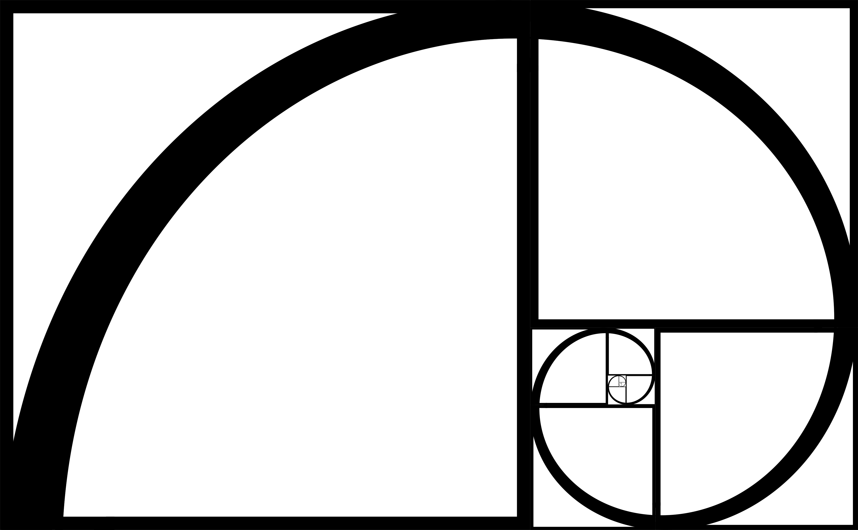
The Fibonacci sequence is the list of numbers
1, 1, 2, 3, 5, 8, 13, 21, 34, 55, 89, 144, …
The sequence begins with two ones. The other numbers are the sum of the two numbers before them.
Golden thank yous use the Fibonacci sequence so that it is easy to make change. For example, an 8 bill equals a 3 bill and a 5 bill. A 55 bill equals a 21 bill and a 34 bill, and so on.

The Fibonacci sequence is the list
1, 1, 2, 3, 5, 8, 13, 21, 34, 55, 89, 144, …
The sequence begins with two ones. The other numbers are the sum of the two numbers before them.
What is the next number in the Fibonacci sequence?

Ans: 10
Print more golden thank yous for free at GoldenThankYous.com.
Math of Golden Thank Yous, Series 2, #8
Math of Golden Thank Yous, Series 2, #6
Math of Golden Thank Yous, Series 2, #4
Math of Golden Thank Yous, Series 2, #2
Math of Golden Thank Yous, Series 2, #7
Math of Golden Thank Yous, Series 2, #5
Math of Golden Thank Yous, Series 2, #3
Math of Golden Thank Yous, Series 2, #1
Print more golden thank yous for free at GoldenThankYous.com.
Print more golden thank yous for free at GoldenThankYous.com.
Print more golden thank yous for free at GoldenThankYous.com.
Print more golden thank yous for free at GoldenThankYous.com.
Print more golden thank yous for free at GoldenThankYous.com.
Print more golden thank yous for free at GoldenThankYous.com.
Print more golden thank yous for free at GoldenThankYous.com.
Learn more at TrevorTheTimeTraveler.com.
Learn more at TrevorTheTimeTraveler.com.
Learn more at TrevorTheTimeTraveler.com.
Learn more at TrevorTheTimeTraveler.com.
Learn more at TrevorTheTimeTraveler.com.
Learn more at TrevorTheTimeTraveler.com.
Learn more at TrevorTheTimeTraveler.com.
Learn more at TrevorTheTimeTraveler.com.
Trevor the Time Traveler by Professor H. L. Bray
(buy it on amazon.com) is a story about Trevor and his sister Farrah who become secret agents for the Fruit Smoothians, the most advanced civilization in the Milky Way galaxy. Their currency is called a golden thank you.
The Fruit Smoothians believe that happiness comes from helping other people. On each golden thank you, they write
“Make the universe a better place, in every possible way, no matter how small, with every decision you make.”
The Fruit Smoothians do their best to live by this rule. They believe that learning everything they can in and out of school will help them do the most good in their lives.

Each golden thank you is labeled with a letter from the alphabet. These letters may be used to make change since each bill is worth the same as the previous two.
For example, suppose you have 2 C bills and you want to pay someone a D bill. Then you may make change like this:
2C = C + C = C + (B + A) = (C + B) + A = D + A
Thus, if you owe someone a D bill, you may pay them
2 C bills and ask them for an A bill as your change.
The front of each bill shows different ways to make change.

Each golden thank you is labeled with a letter from the alphabet. These letters may be used to make change since each bill is worth the same as the previous two.
For example, suppose you have 3 C bills and you want to pay someone an E bill. Then you may make change like this:
3C = C + C + C
= C + C + (B + A) = C + (C + B) + A
= C + (D) + A = (C + D) + A
= E + A
Thus, if you owe someone an E bill, you may pay them
3 C bills and ask them for an A bill as your change.

Trevor the Time Traveler by Professor H. L. Bray
(buy it on amazon.com) is a story about Trevor and his sister Farrah who become secret agents for the Fruit Smoothians, the most advanced civilization in the Milky Way galaxy. Their currency is called a golden thank you.
The Fruit Smoothians write smart problems and interesting facts on the backs of golden thanks yous. They believe that the key to getting smarter is working hard on smart problems. Sometimes they work on problems for hours and ask their teachers, parents, and friends for help when they need it. The harder they try, the smarter they become.

Each golden thank you is labeled with a letter from the alphabet. These letters may be used to make change since each bill is worth the same as the previous two.

For example, an E bill is worth the same as a D and a C.
The D bill can then be exchanged for a C bill and a B bill.
Hence, an E is worth the same as 2 C’s and 1 B.

We may write this symbolically as

E = D + C
= (C + B) + C
= 2C + B.

Each bill is worth the same as the previous two bills. Since each bill has a letter on it, we may write this symbolically as
E = D + C
= (C + B) + C
= 2C + B.
But since a C bill is worth the same as a B bill and an A bill,
two C bills are worth the same as two B’s and two A’s. Thus,
E = 2C + B
= (2B + 2A) + B
= 3B + 2A.
Hence, to make change, an E bill is worth the same as
- one D bill and one C bill, written as D + C, or
- two C bills and one B bill, written as 2C + B, or
- three B bills and two A bills, written as 3B + 2A.
The front of each bill shows different ways to make change.

What number times itself equals 9? Answer: 3
What number times itself equals 25? Answer: 5
To save space, we say that the square root of 9 is 3 and the square root of 25 is 5. To save even more space, we write
$\sqrt{4} = 2 and \sqrt{9}$ = 3 and $\sqrt{16}$ = 4 and $\sqrt{25}$ = 5.
Since 5 is between 4 and 9, $\sqrt{5}$ is between 2 and 3.
Using a calculator, we find that $\sqrt{5}$ is about 2.2.
What is $\sqrt{100}$ ?
That is, what number times itself equals 100?

Trevor the Time Traveler by Professor H. L. Bray
(buy it on amazon.com) is a story about Trevor and his sister Farrah who become secret agents for the Fruit Smoothians, the most advanced civilization in the Milky Way galaxy. In the story, the Fruit Smoothians have protected everyone in the Milky Way galaxy, including the Earth, for billions of years.
In honor of this, everyone in the Milky Way galaxy uses the Fruit Smoothians’ currency whose name translates into English roughly as a “golden thank you.” Fruit Smoothians give golden thank yous to each other whenever someone does something nice or good for them or someone else.

Carl Gauss (1777 – 1855)
was a great German mathematician who did important work in number theory, algebra, statistics, mechanics, electrostatics, and astronomy. He also established differential geometry, later used by Einstein to redefine gravity using general relativity.

Richard Feynman (1918 – 1988)
was an American theoretical physicist known for his fundamental work in quantum electrodynamics, with deep consequences for the physics of elementary particles. He introduced Feynman diagrams, a graphical representation of interactions between different particles. He received the Nobel Prize in Physics in 1965.

Edwin Hubble (1889 – 1953)
was an American astronomer who showed that there were many other galaxies beyond the Milky Way Galaxy in which we live. He also measured galaxies’ velocities to be proportional to their distances from us, suggesting an expanding universe and a Big Bang, as predicted by general relativity.

Emmy Noether (1882 – 1935)
was a great German mathematician who did important work in abstract algebra and theoretical physics. Noether’s theorem explains the connection between symmetries of the universe and conservation laws, like conservation of energy and momentum, which are central to physics.
Albert Einstein (1879 – 1955)
unified space and time with special relativity and redefined gravity using general relativity, the idea that matter curves spacetime. His theory predicted the Big Bang, black holes, dark energy and the curvature of light around the Sun. Unlike Newton’s theory, it also explains gravity as accurately as can be measured.
Marie Curie (1867 – 1934)
was a Polish and naturalized French physicist and chemist who did early research on radioactivity and discovered two elements, radium and polonium. She was the first person to win two Nobel Prizes and the only person to win in multiple sciences, physics and chemistry.

Charles Darwin (1809 – 1882)
was an English naturalist and geologist who proposed that all species of life are related. His theory, called natural selection, shows how small changes between parents and their children which help with survival can lead to the great diversity of life seen on the Earth today.

Isaac Newton (1643 – 1727)
was an English physicist and mathematician who was the first to show that gravity, which causes a rock to fall to the ground, is also what describes the motions of planets, moons, and comets. He also invented calculus to be able to express his theory in precise mathematical terms.

Print more golden thank yous for free at GoldenThankYous.com.
Great Scientists, Series 1, #8
Great Scientists, Series 1, #6
Great Scientists, Series 1, #4
Great Scientists, Series 1, #2
Great Scientists, Series 1, #7
Great Scientists, Series 1, #5
Great Scientists, Series 1, #3
Great Scientists, Series 1, #1
Print more golden thank yous for free at GoldenThankYous.com.
Print more golden thank yous for free at GoldenThankYous.com.
Print more golden thank yous for free at GoldenThankYous.com.
Print more golden thank yous for free at GoldenThankYous.com.
Print more golden thank yous for free at GoldenThankYous.com.
Print more golden thank yous for free at GoldenThankYous.com.
Print more golden thank yous for free at GoldenThankYous.com.
Learn more at TrevorTheTimeTraveler.com.
Learn more at TrevorTheTimeTraveler.com.
Learn more at TrevorTheTimeTraveler.com.
Learn more at TrevorTheTimeTraveler.com.
Learn more at TrevorTheTimeTraveler.com.
Learn more at TrevorTheTimeTraveler.com.
Learn more at TrevorTheTimeTraveler.com.
Learn more at TrevorTheTimeTraveler.com.

Print more golden thank yous for free at GoldenThankYous.com.
The Magic of Nine, #8
The Magic of Nine, #6
The Magic of Nine, #4
The Magic of Nine, #2
The Magic of Nine, #7
The Magic of Nine, #5
The Magic of Nine, #3
The Magic of Nine, #1
Print more golden thank yous for free at GoldenThankYous.com.
Print more golden thank yous for free at GoldenThankYous.com.
Print more golden thank yous for free at GoldenThankYous.com.
Print more golden thank yous for free at GoldenThankYous.com.
Print more golden thank yous for free at GoldenThankYous.com.
Print more golden thank yous for free at GoldenThankYous.com.
Print more golden thank yous for free at GoldenThankYous.com.
Learn more at TrevorTheTimeTraveler.com.
Learn more at TrevorTheTimeTraveler.com.
Learn more at TrevorTheTimeTraveler.com.
Learn more at TrevorTheTimeTraveler.com.
Learn more at TrevorTheTimeTraveler.com.
Learn more at TrevorTheTimeTraveler.com.
Learn more at TrevorTheTimeTraveler.com.
Learn more at TrevorTheTimeTraveler.com.
Multiples of 9:
9 = 9 x 1 = 9 Adding 9 is the same as
18 = 9 x 2 = 9 + 9 adding 10 and subtracting 1.
27 = 9 x 3 = 9 + 9 + 9
36 = 9 x 4 = 9 + 9 + 9 + 9
45 = 9 x 5 = 9 + 9 + 9 + 9 + 9
54 = 9 x 6 = 9 + 9 + 9 + 9 + 9 + 9
63 = 9 x 7 = 9 + 9 + 9 + 9 + 9 + 9 + 9
72 = 9 x 8 = 9 + 9 + 9 + 9 + 9 + 9 + 9 + 9
81 = 9 x 9 = 9 + 9 + 9 + 9 + 9 + 9 + 9 + 9 + 9
90 = 9 x 10 = 9 + 9 + 9 + 9 + 9 + 9 + 9 + 9 + 9 + 9
Notice any patterns on the left hand side? Why is this?

Adding 9 is the same as adding 10 and subtracting 1. Hence, in many cases the tens digit goes up by 1 and the ones digit goes down by 1:
74 + 9 = (70 + 4) + (10 – 1) = (70 + 10) + (4 – 1) = 80 + 3 = 83
82 + 9 = (80 + 2) + (10 – 1) = (80 + 10) + (2 – 1) = 90 + 1 = 91
36 + 9 = … 3 goes up to 4, 6 goes down to 5 … = 45
28 + 9 = … 2 goes up to 3, 8 goes down to 7 … = 37
When one digit goes up and one digit goes down, the sum of the digits stays the same. For example, 74 + 9 = 83 and
7 + 4 = 11 = 8 + 3.

Since adding 9 is the same as adding 10 and subtracting 1, we get a nice pattern for multiples of 9:
9 = 9 x 1 = 9
18 = 9 x 2 = 9 + 9 The tens digit goes up by one and
27 = 9 x 3 = 18 + 9 the ones digit goes down by one each
36 = 9 x 4 = 27 + 9 time we add 9. Hence, the sum of the
45 = 9 x 5 = 36 + 9 two digits stays the same at 9. Also,
54 = 9 x 6 = 45 + 9 notice that the tens digit is always one
63 = 9 x 7 = 54 + 9 less than the number we are multiplying
72 = 9 x 8 = 63 + 9 by 9. This makes it easy to multiply the
81 = 9 x 9 = 72 + 9 numbers 1 through 10 by 9:
90 = 9 x 10 = 81 + 9
Trick for multiplying the numbers 1 thru 10 by 9:
9 x 7 = … starts with 6 (one less than 7),
ends with 3 (since 6 + 3 = 9) … = 63

Nice trick for multiplying the numbers 1 thru 10 by 9:
9 x 7 = … starts with 6 (one less than 7),
ends with 3 (since 6 + 3 = 9) … = 63
9 x 2 = … starts with 1 (one less than 2),
ends with 8 (since 1 + 8 = 9) … = 18
9 x 8 = … starts with 7 (one less than 8),
ends with 2 (since 7 + 2 = 9) … = 72
9 x 5 = … starts with 4 (one less than 5),
ends with 5 (since 4 + 5 = 9) … = 45
9 x 4 = … starts with 3 (one less than 4),
ends with 6 (since 3 + 6 = 9) … = 36
Why does this trick work?

The sum of the digits of any multiple of 9 is also a multiple of 9.
We can list multiples of 9 by counting by 9’s:
0, 9, 18, 27, 36, 45, 54, 63, 72, 81, 90, 99, 108, 117, 126, 135, …
Notice that 9 + 9 = 18 and 1 + 3 + 5 = 9 are both multiples of 9. Also, the 111th number in the above list is 111 x 9 = 999, and 9 + 9 + 9 = 27, another multiple of 9. Why is this always true?
Answer: Adding 9 to a number increases the ones digit by 9, except for carries which decrease the lower digit by 10 and increase the higher digit by 1 (thereby decreasing the sum of the digits by 9). Hence, adding 9 to a number causes the sum of the digits to change by a multiple of 9.
Since the first number in the list is 0 whose digits sum to a multiple of 9 (since
9 x 0 = 0), the next number in the list will have this property, as will the next, and the next, and so on. Hence, every number in the above list will have this property.
Thus, the sum of the digits of any multiple of 9 is also a multiple of 9.

Magic Trick
1) Take any positive whole number: 487
2) Multiply it by 9: 487 x 9 = 4383
3) Add up all of those digits: 4 + 3 + 8 + 3 = 18
4) Add up all of those digits: 1 + 8 = 9
5) Keep doing this until you get a number with only one digit. This last number will always be 9!
Don’t believe it? Try it with other numbers!
The reason this trick works is that the sum of the digits of a multiple of 9 is also a multiple of 9, as explained on bill #7 in “The Magic of Nine” series. Hence, since 4383 is a multiple of 9, the sum of its digits, 18, must also be a multiple of 9. Thus, the sum of 18’s digits, 9, also must be a multiple of 9, which of course it is.
The above process of summing digits produces a series of numbers, all of which are multiples of 9. It stops with a single digit which is also a multiple of 9. Since 9 is the only single digit which is a multiple of 9, the final number must be 9.

Counting by 5’s:
5, 10, 15, 20, 25, 30, 35, 40, 45, 50, 55, 60, 65, 70, 75, 80, 85, 90, 95, 100,
105, 110, 115, 120, 125, 130, 135, 140, 145, 150, 155, 160, 165, 170, 175, 180, 185, 190, 195, 200,
205, 210, 215, 220, 225, 230, 235, 240, 245, 250, 255, 260, 265, 270, 275, 280, 285, 290, 295, 300,
305, 310, 315, 320, 325, 330, 335, 340, 345, 350, 355, 360, 365, 370, 375, 380, 385, 390, 395, 400,
405, 410, 415, 420, 425, 430, 435, 440, 445, 450, 455, 460, 465, 470, 475, 480, 485, 490, 495, 500,
505, 510, 515, 520, 525, 530, 535, 540, 545, 550, 555, 560, 565, 570, 575, 580, 585, 590, 595, 600,
605, 610, 615, 620, 625, 630, 635, 640, 645, 650, 655, 660, 665, 670, 675, 680, 685, 690, 695, 700,
705, 710, 715, 720, 725, 730, 735, 740, 745, 750, 755, 760, 765, 770, 775, 780, 785, 790, 795, 800,
805, 810, 815, 820, 825, 830, 835, 840, 845, 850, 855, 860, 865, 870, 875, 880, 885, 890, 895, 900,
905, 910, 915, 920, 925, 930, 935, 940, 945, 950, 955, 960, 965, 970, 975, 980, 985, 990, 995, 1000, 1005, 1010, 1015, 1020, 1025, 1030, 1035, 1040, 1045, 1050, 1055, 1060, 1065, 1070, 1075, 1080, 1085, 1090, 1095, 1100,
1105, 1110, 1115, 1120, 1125, 1130, 1135, 1140, 1145, 1150, 1155, 1160, 1165, 1170, 1175, 1180, 1185, 1190, 1195, 1200,
1205, 1210, 1215, 1220, 1225, 1230, 1235, 1240, 1245, 1250, 1255, 1260, 1265, 1270, 1275, 1280, 1285, 1290, 1295, 1300,
1305, 1310, 1315, 1320, 1325, 1330, 1335, 1340, 1345, 1350, 1355, 1360, 1365, 1370, 1375, 1380, 1385, 1390, 1395, 1400,
1405, 1410, 1415, 1420, 1425, 1430, 1435, 1440, 1445, 1450, 1455, 1460, 1465, 1470, 1475, 1480, 1485, 1490, 1495, 1500,
1505, 1510, 1515, 1520, 1525, 1530, 1535, 1540, 1545, 1550, 1555, 1560, 1565, 1570, 1575, 1580, 1585, 1590, 1595, 1600,
1605, 1610, 1615, 1620, 1625, 1630, 1635, 1640, 1645, 1650, 1655, 1660, 1665, 1670, 1675, 1680, 1685, 1690, 1695, 1700,
1705, 1710, 1715, 1720, 1725, 1730, 1735, 1740, 1745, 1750, 1755, 1760, 1765, 1770, 1775, 1780, 1785, 1790, 1795, 1800,
1805, 1810, 1815, 1820, 1825, 1830, 1835, 1840, 1845, 1850, 1855, 1860, 1865, 1870, 1875, 1880, 1885, 1890, 1895, 1900,
1905, 1910, 1915, 1920, 1925, 1930, 1935, 1940, 1945, 1950, 1955, 1960, 1965, 1970, 1975, 1980, 1985, 1990, 1995, 2000.
How high can you count by 5’s?

Every whole number is within 2 of a multiple of 5. For example,

1 = 0 + 1 Why is this?
2 = 0 + 2
3 = 5 – 2 Using these facts, can you think of a
4 = 5 – 1 fast and easy way to compute 6 + 7?
5 = 5 + 0
6 = 5 + 1 Using these facts, can you think of a
7 = 5 + 2 fast and easy way to compute 9 + 9?
8 = 10 – 2
9 = 10 – 1 Hint: 8 + 9 = (10 – 2) + (10 – 1) = 20 – 3 = 17.
10 = 10 + 0 Or: 8 + 9 = 8 + (10 – 1) = 10 + (8 – 1) = 17.
Or: 8 + 9 = (10 – 2) + 9 = 10 + (9 – 2) = 17.

Answer: even, odd, even.

5

8

13

21
34

55

89

144

Squares with sides equal to the Fibonacci numbers may be arranged as shown in this picture. The squares fit perfectly together since the side length of each square is exactly the sum of the previous two smaller squares. As the numbers get larger, they go up by a factor which converges to the golden ratio
$$\frac{1+\sqrt{5}}{2}$$
which is about 1.6. The spiral in the picture goes around infinitely many times. Each time it goes around one quarter turn, it shrinks by a factor equal to the golden ratio. This is why this spiral is called the golden spiral.

Ans: 233
Print more golden thank yous for free at GoldenThankYous.com.
Math of Golden Thank Yous, Series 1, #8
Math of Golden Thank Yous, Series 1, #6
Math of Golden Thank Yous, Series 1, #4
Math of Golden Thank Yous, Series 1, #2
Math of Golden Thank Yous, Series 1, #7
Math of Golden Thank Yous, Series 1, #5
Math of Golden Thank Yous, Series 1, #3
Math of Golden Thank Yous, Series 1, #1
Print more golden thank yous for free at GoldenThankYous.com.
Print more golden thank yous for free at GoldenThankYous.com.
Print more golden thank yous for free at GoldenThankYous.com.
Print more golden thank yous for free at GoldenThankYous.com.
Print more golden thank yous for free at GoldenThankYous.com.
Print more golden thank yous for free at GoldenThankYous.com.
Print more golden thank yous for free at GoldenThankYous.com.
Learn more at TrevorTheTimeTraveler.com.
Learn more at TrevorTheTimeTraveler.com.
Learn more at TrevorTheTimeTraveler.com.
Learn more at TrevorTheTimeTraveler.com.
Learn more at TrevorTheTimeTraveler.com.
Learn more at TrevorTheTimeTraveler.com.
Learn more at TrevorTheTimeTraveler.com.
Learn more at TrevorTheTimeTraveler.com.
Counting by two’s gives us the even numbers:
0, 2, 4, 6, 8, 10, 12, 14, 16, 18, 20, 22, 24, …
Adding one to each number gives odd numbers:
1, 3, 5, 7, 9, 11, 13, 15, 17, 19, 21, 23, 25, …
What patterns can you see?
What digits come at the end of even numbers?
What digits come at the end of odd numbers?
Why is this?

Even numbers come out evenly when you split them into two rows. Odd numbers do not.

1 . (odd) Pictures help us see ideas.
2 : (even)
3 :. (odd) 4 + 6 = 10
4 :: (even) :: + ::: = :::::
5 ::. (odd) (even) + (even) = (even)
6 ::: (even)
7 :::. (odd) The picture above shows why
8 :::: (even) any even number plus
9 ::::. (odd) another even number always 10 ::::: (even) equals an even number.

Even numbers come out evenly when you split them into two rows. Odd numbers do not.

1 . (odd) Pictures help us see ideas.
2 : (even)
3 :. (odd) 4 + 7 = 11
4 :: (even) :: + :::. = :::::.
5 ::. (odd) (even) + (odd) = (odd)
6 ::: (even)
7 :::. (odd) The picture above shows why
8 :::: (even) any even number plus
9 ::::. (odd) any odd number always
10 ::::: (even) equals an odd number.

Even numbers come out evenly when you split them into two rows. Odd numbers do not.

1 . (odd) Pictures help us see ideas.
2 : (even)
3 :. (odd) 5 + 7 = 12
4 :: (even) ::. + :::. = ::::::
5 ::. (odd) (odd) + (odd) = (even)
6 ::: (even)
7 :::. (odd) The picture above shows why
8 :::: (even) any odd number plus
9 ::::. (odd) any other odd number always
10 ::::: (even) equals an even number.

The Fibonacci sequence begins with two ones. The other numbers are the sum of the two numbers before them.

1 (odd) Notice that every third number is even and
1 (odd) all of the other numbers are odd.
2 (even)
3 (odd) Why is this?
5 (odd)
8 (even) Do you think this pattern continues forever?
13 (odd)
21 (odd) Is the 30th number even or odd?
34 (even)
55 (odd) Is the 31st number even or odd?
89 (odd)
144 (even) Is the 300th number even or odd?

The Fibonacci sequence is the list of numbers
1, 1, 2, 3, 5, 8, 13, 21, 34, 55, 89, 144, …
The sequence begins with two ones. The other numbers are the sum of the two numbers before them.
Golden thank yous use the Fibonacci sequence so that it is easy to make change. For example, an 8 bill equals a 3 bill and a 5 bill. A 55 bill equals a 21 bill and a 34 bill, and so on.

The Fibonacci sequence is the list
1, 1, 2, 3, 5, 8, 13, 21, 34, 55, 89, 144, …
The sequence begins with two ones. The other numbers are the sum of the two numbers before them.
What is the next number in the Fibonacci sequence?

Ans: 10
Print more golden thank yous for free at GoldenThankYous.com.
Math of Golden Thank Yous, Series 2, #8
Math of Golden Thank Yous, Series 2, #6
Math of Golden Thank Yous, Series 2, #4
Math of Golden Thank Yous, Series 2, #2
Math of Golden Thank Yous, Series 2, #7
Math of Golden Thank Yous, Series 2, #5
Math of Golden Thank Yous, Series 2, #3
Math of Golden Thank Yous, Series 2, #1
Print more golden thank yous for free at GoldenThankYous.com.
Print more golden thank yous for free at GoldenThankYous.com.
Print more golden thank yous for free at GoldenThankYous.com.
Print more golden thank yous for free at GoldenThankYous.com.
Print more golden thank yous for free at GoldenThankYous.com.
Print more golden thank yous for free at GoldenThankYous.com.
Print more golden thank yous for free at GoldenThankYous.com.
Learn more at TrevorTheTimeTraveler.com.
Learn more at TrevorTheTimeTraveler.com.
Learn more at TrevorTheTimeTraveler.com.
Learn more at TrevorTheTimeTraveler.com.
Learn more at TrevorTheTimeTraveler.com.
Learn more at TrevorTheTimeTraveler.com.
Learn more at TrevorTheTimeTraveler.com.
Learn more at TrevorTheTimeTraveler.com.
Trevor the Time Traveler by Professor H. L. Bray
(buy it on amazon.com) is a story about Trevor and his sister Farrah who become secret agents for the Fruit Smoothians, the most advanced civilization in the Milky Way galaxy. Their currency is called a golden thank you.
The Fruit Smoothians believe that happiness comes from helping other people. On each golden thank you, they write
“Make the universe a better place, in every possible way, no matter how small, with every decision you make.”
The Fruit Smoothians do their best to live by this rule. They believe that learning everything they can in and out of school will help them do the most good in their lives.

Each golden thank you is labeled with a letter from the alphabet. These letters may be used to make change since each bill is worth the same as the previous two.
For example, suppose you have 2 C bills and you want to pay someone a D bill. Then you may make change like this:
2C = C + C = C + (B + A) = (C + B) + A = D + A
Thus, if you owe someone a D bill, you may pay them
2 C bills and ask them for an A bill as your change.
The front of each bill shows different ways to make change.

Each golden thank you is labeled with a letter from the alphabet. These letters may be used to make change since each bill is worth the same as the previous two.
For example, suppose you have 3 C bills and you want to pay someone an E bill. Then you may make change like this:
3C = C + C + C
= C + C + (B + A) = C + (C + B) + A
= C + (D) + A = (C + D) + A
= E + A
Thus, if you owe someone an E bill, you may pay them
3 C bills and ask them for an A bill as your change.

Trevor the Time Traveler by Professor H. L. Bray
(buy it on amazon.com) is a story about Trevor and his sister Farrah who become secret agents for the Fruit Smoothians, the most advanced civilization in the Milky Way galaxy. Their currency is called a golden thank you.
The Fruit Smoothians write smart problems and interesting facts on the backs of golden thanks yous. They believe that the key to getting smarter is working hard on smart problems. Sometimes they work on problems for hours and ask their teachers, parents, and friends for help when they need it. The harder they try, the smarter they become.

Each golden thank you is labeled with a letter from the alphabet. These letters may be used to make change since each bill is worth the same as the previous two.

For example, an E bill is worth the same as a D and a C.
The D bill can then be exchanged for a C bill and a B bill.
Hence, an E is worth the same as 2 C’s and 1 B.

We may write this symbolically as

E = D + C
= (C + B) + C
= 2C + B.

Each bill is worth the same as the previous two bills. Since each bill has a letter on it, we may write this symbolically as
E = D + C
= (C + B) + C
= 2C + B.
But since a C bill is worth the same as a B bill and an A bill,
two C bills are worth the same as two B’s and two A’s. Thus,
E = 2C + B
= (2B + 2A) + B
= 3B + 2A.
Hence, to make change, an E bill is worth the same as
- one D bill and one C bill, written as D + C, or
- two C bills and one B bill, written as 2C + B, or
- three B bills and two A bills, written as 3B + 2A.
The front of each bill shows different ways to make change.

What number times itself equals 9? Answer: 3
What number times itself equals 25? Answer: 5
To save space, we say that the square root of 9 is 3 and the square root of 25 is 5. To save even more space, we write
$\sqrt{4} = 2 and \sqrt{9}$ = 3 and $\sqrt{16}$ = 4 and $\sqrt{25}$ = 5.
Since 5 is between 4 and 9, $\sqrt{5}$ is between 2 and 3.
Using a calculator, we find that $\sqrt{5}$ is about 2.2.
What is $\sqrt{100}$ ?
That is, what number times itself equals 100?

Trevor the Time Traveler by Professor H. L. Bray
(buy it on amazon.com) is a story about Trevor and his sister Farrah who become secret agents for the Fruit Smoothians, the most advanced civilization in the Milky Way galaxy. In the story, the Fruit Smoothians have protected everyone in the Milky Way galaxy, including the Earth, for billions of years.
In honor of this, everyone in the Milky Way galaxy uses the Fruit Smoothians’ currency whose name translates into English roughly as a “golden thank you.” Fruit Smoothians give golden thank yous to each other whenever someone does something nice or good for them or someone else.

